Data Communication between LWC Components
Refer parentComponent and childComponent
In the child component, you will use the decorator @api for all the variables that can be over-written from parent component.
There are three types of communication between LWC Components:

- Parent to Child Communication
- Child to Parent Communication
- Communication between unrelated components

1. Parent to Child Communication
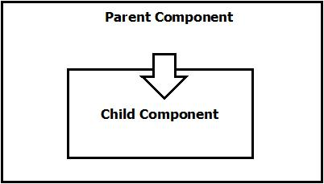

It is done by public properties using @api decorator.

Kebab Case: Respective phrase will be transferred to all lowercase with hyphen(-) separating words.
e.g. headerLabel will be header-label

Program Code (childComponent1.html)
<template>
<lightning-card title="Parent to Child Communication">
Hello <b>{fullName}!</b>
</lightning-card>
</template>

Program Code (childComponent1.js)
import { LightningElement, api } from 'lwc';

export default class ChildComponent1 extends LightningElement {
@api fullName='Parag Jambhulkar';
}

Program Code (childComponent1.js-meta.xml)
<?xml version="1.0" encoding="UTF-8"?>
<LightningComponentBundle xmlns="http://soap.sforce.com/2006/04/metadata">
<apiVersion>58.0</apiVersion>
<isExposed>false</isExposed>
</LightningComponentBundle>

Program Code (parentComponent.html)
<template>
<lightning-card>
<c-child-component1 full-name={name}></c-child-component1>
</lightning-card>
</template>

Program Code (prentComponent.js)
import { LightningElement } from 'lwc';

export default class ParentComponent1 extends LightningElement {
name="Mayur Chavan";
}

Program Code (parentComponent.js-meta.xml)
<?xml version="1.0" encoding="UTF-8"?>
<LightningComponentBundle xmlns="http://soap.sforce.com/2006/04/metadata">
<apiVersion>58.0</apiVersion>
<isExposed>true</isExposed>
<targets>
<target>lightning__AppPage</target>
</targets>
</LightningComponentBundle>

